**Cyber Security**

**Assignment 03**

**Code:**

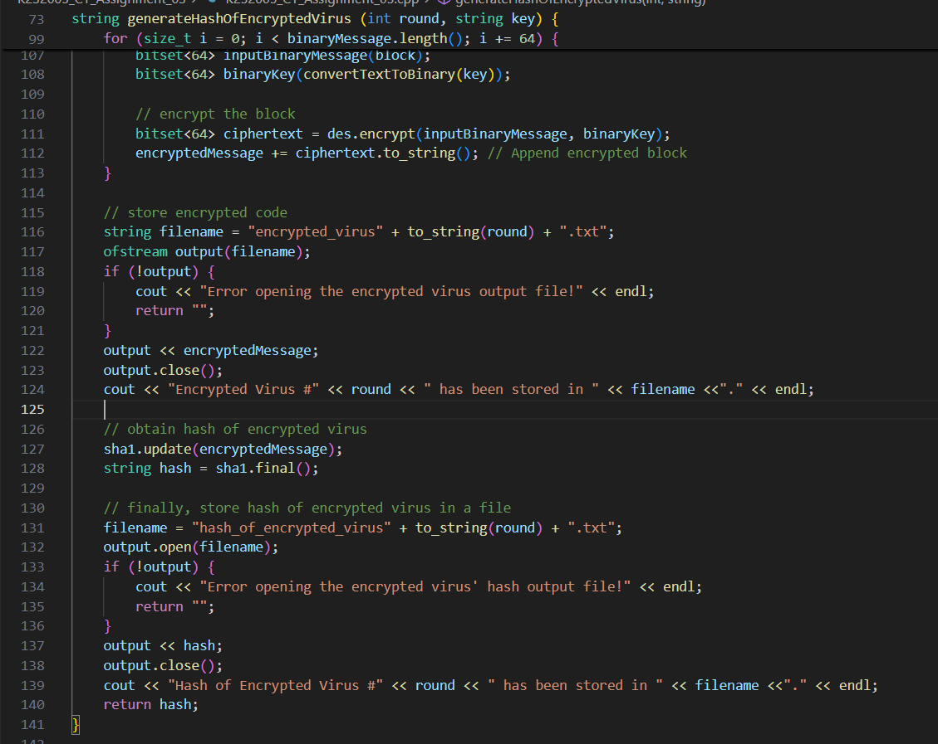

**Output**

**Case 01: Distinct Hashes**

**Encrypted Virus Files**







**Hashes of Encrypted Viruses**

**Case 02: Same Hashes (Collision)**

**Encrypted Virus Files**







**Hashes of Encrypted Viruses**

